***Group 4 Final Doc***

***Abstract***

***Introduction to the document***

***Description of the company***

Group 4 solutions is a new company made up of four individuals from different backgrounds to provide turnkey solutions to your software needs. We have around ten years coding experience within Java in academia and industry, working on numerous different types of projects. We have a strong background in delivering solutions on time and within budget by using strong software engineering techniques. As a company we believe that to give the client what they need we must first understand the requirements and we take a large amount of time making sure that we know what the requirements are. Using our experience in industry we are able to talk to business’s about their company and help them to accurately describe what they want. Once we know what is required we are able to use our industry and academic experience to find elegant and sophisticated solutions which we are able to deliver on time.

The company is owned and operated by four equal shareholders all with differing experiences which combine to make Group 4 solutions a high value proposition for business’s looking at their software needs. Wang is the technical director and has many years’ experience working on technical projects in Java in academia and industry. He drives the company forward looking at cutting edge techniques to ensure that we deliver the best and most suitable products. Donal has been in academia for many years working on complex problems in physics and maths. He has strong problem solving skills and is our testing director, he is responsible for making sure that all of products have no bugs and fulfil the requirements. Donovan is an all-round technical guy, he is responsible for working on all technical aspects of the project. He has a huge role in the design of the project by working on the diagrams which ensure that we will not go over time and over budget. Richard has many years’ industrial experience working for the end user, he is skilled in project management and organisation/administration. His main tasks involve liaising with all the parties and ensuring the brief is correct and keeping lines of communication open all the way through the project cycle.

***Quality section on tools, schedule***

***User Requirements***

* A 2D CGS model of a shape or set of shapes that is stored internally as a tree.
* The tree shall consist of nodes which shall be either shapes, transforms, mixes or references to other nodes. It should be possible to create a new tree, to modify an existing tree by adding or removing nodes within it and to delete an existing tree.
* It should be possible to create new nodes and to delete existing nodes. A unique ID will be assigned to all nodes.
* Shapes shall be either circles, defined by their radius, or regular polygons defined by their number of sides and radius. Only 3- and 4-sided polygons need to be considered. All shapes shall have their default position at the origin of the 2D coordinate system in which they exist. A shape node shall always be a leaf.
* Transforms shall be either rotation by some angle in radians, scaling by some real number factor in x and y or translation in x and y by some real number amount. It should also be possible to apply a particular transform to a node multiple times with a single instruction. A transform shall be applied to one existing node.
* Mixes shall be either the + (Union), - (Difference) or & (Intersection) of two existing nodes.
* There shall be some user interface that allows interacting with a representation of the tree and also shows a graphical representation of the tree as a 2D image.
* It should be possible to save the current state as a file and to load it back anytime. Each time a saved file is loaded, it should be possible to resume editing the drawing.

***Preliminary design***

***Test Sections***

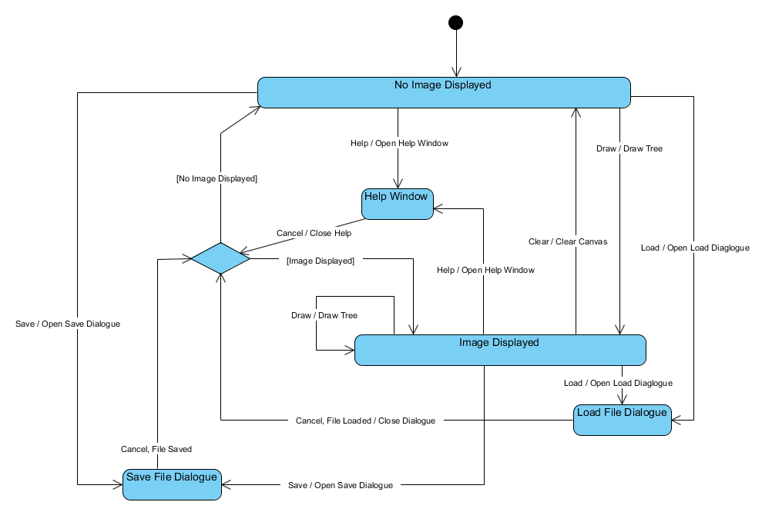A state diagram representing the GUI, shown below, was created to enable testing of the expected behaviour of the application.

From the state diagram it can be seen that the application should start with a blank canvas (no image displayed) and that it should be possible to open the load file dialogue by pressing “load”, the save file dialogue by pressing “save” and the help window by pressing “help” from this state, and to return to it from them. It should also be possible to enter the “image displayed” state by pressing the “Draw” button, providing a valid tree has been entered. Likewise, from the “image displayed” state, it should be possible to open the load file dialogue, the save file dialogue and the help window, and to return to it from them; that is, the displayed image should not be removed when the “load”, “save” or “help” buttons are pressed. It should also be possible to return to the “no image displayed” state by pressing the “clear” button, and to redraw the current image or draw a new image by pressing the “draw” button.

As well as testing the behaviour of the GUI, it is also important to test the operation of the program as a whole by confirming that certain inputs conform to the expected outputs. As there are in theory an infinite number of possible combinations of instructions that can be input by the user of the system, it is not possible to exhaustively test all cases. Furthermore, since the expected output of the system consists of geometric shapes printed to the screen, it is difficult to quantitatively confirm that any given output exactly matches that expected for a given input. However, a qualitative test suite can be created that confirms that the system conforms to the expected behaviour when considering the general nature of the output.

Test1: Square(50) should produce a square at the centre of the drawing area with sides 100 pixels long.

Test2: Circle(50) should produce a circle at the centre of the drawing area with a diameter of 100 pixels.

Test3: Triangle(50) should produce an equilateral triangle at the centre of the drawing area with side length $50\sqrt{3}$ pixels (approximately 86 pixels).

Test4: Rotate(Square(50),45) should produce a square with sides 100 pixels long at the centre of the drawing area that has been rotated 45 degrees anti-clockwise.

Test5: Translate(Circle(50),25,25) should produce a circle with a diameter of 100 pixels centred on the point 25 pixels above and 25 pixels to the right of the centre of the drawing area.

Test6: Scale(Triangle(50),2,4) should produce a isosceles triangle with base $100\sqrt{3}$ pixels (approximately 173 pixels) and height 300 pixels at the centre of the drawing area.

Test7: Union(Triangle(50),Square(30)) should produce an overlaid image of a square with sides 60 pixels long and an equilateral triangle with sides $50\sqrt{3}$ pixels long, both at the centre of the drawing area.

Test8: Intersection(Circle(50),Square(45)) should produce a square with rounded corners, with the diameter of the rounded portion being 100 pixels and the overall height and width of the shape being 90 pixels, positioned at the centre of the drawing area.

Test9: Difference(Square(50),Circle(50)) should produce a square with side length 100 pixels with, removed from the centre of it, a circle with diameter 100 pixels, both at the centre of the drawing area.

With this very basic test suite it is possible to confirm that each node type can correctly be displayed, and that every type of shape node can be correctly passed to a transform or mix node as an argument. For invalid inputs (such as syntax errors in instructions or arguments outside the valid input domains), error messages will be displayed to the user. A basic implementation of error reporting will indicate only that an error occurred with the input, but more advanced versions will specify the nature of the error.

***Results section***

***Conclusion***

***Appendix***

*Minutes*

*Code*

*Contribution report*